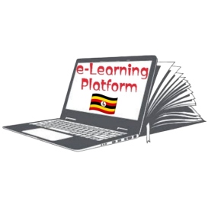**FRESH TEACHER'S E-LIBRARY**

**BEGINNING OF TERM III EXAMINATION 2023**

**MIDDLE CLASS: (4 – 5 YEARS)**

**LEARNING AREA 1: SOCIAL DEVELOPMENT**

**My name is: ……………………………………………………………….**

**My School is: …………………………………….………………………..**

**I am in: ………………………………..…………………………….…………………..**

1. **Draw and colour these people.**

|  |  |
| --- | --- |
|  |  |
| teacher | doctor |
|  |  |
| policeman | cook |

1. **Name these pictures.**

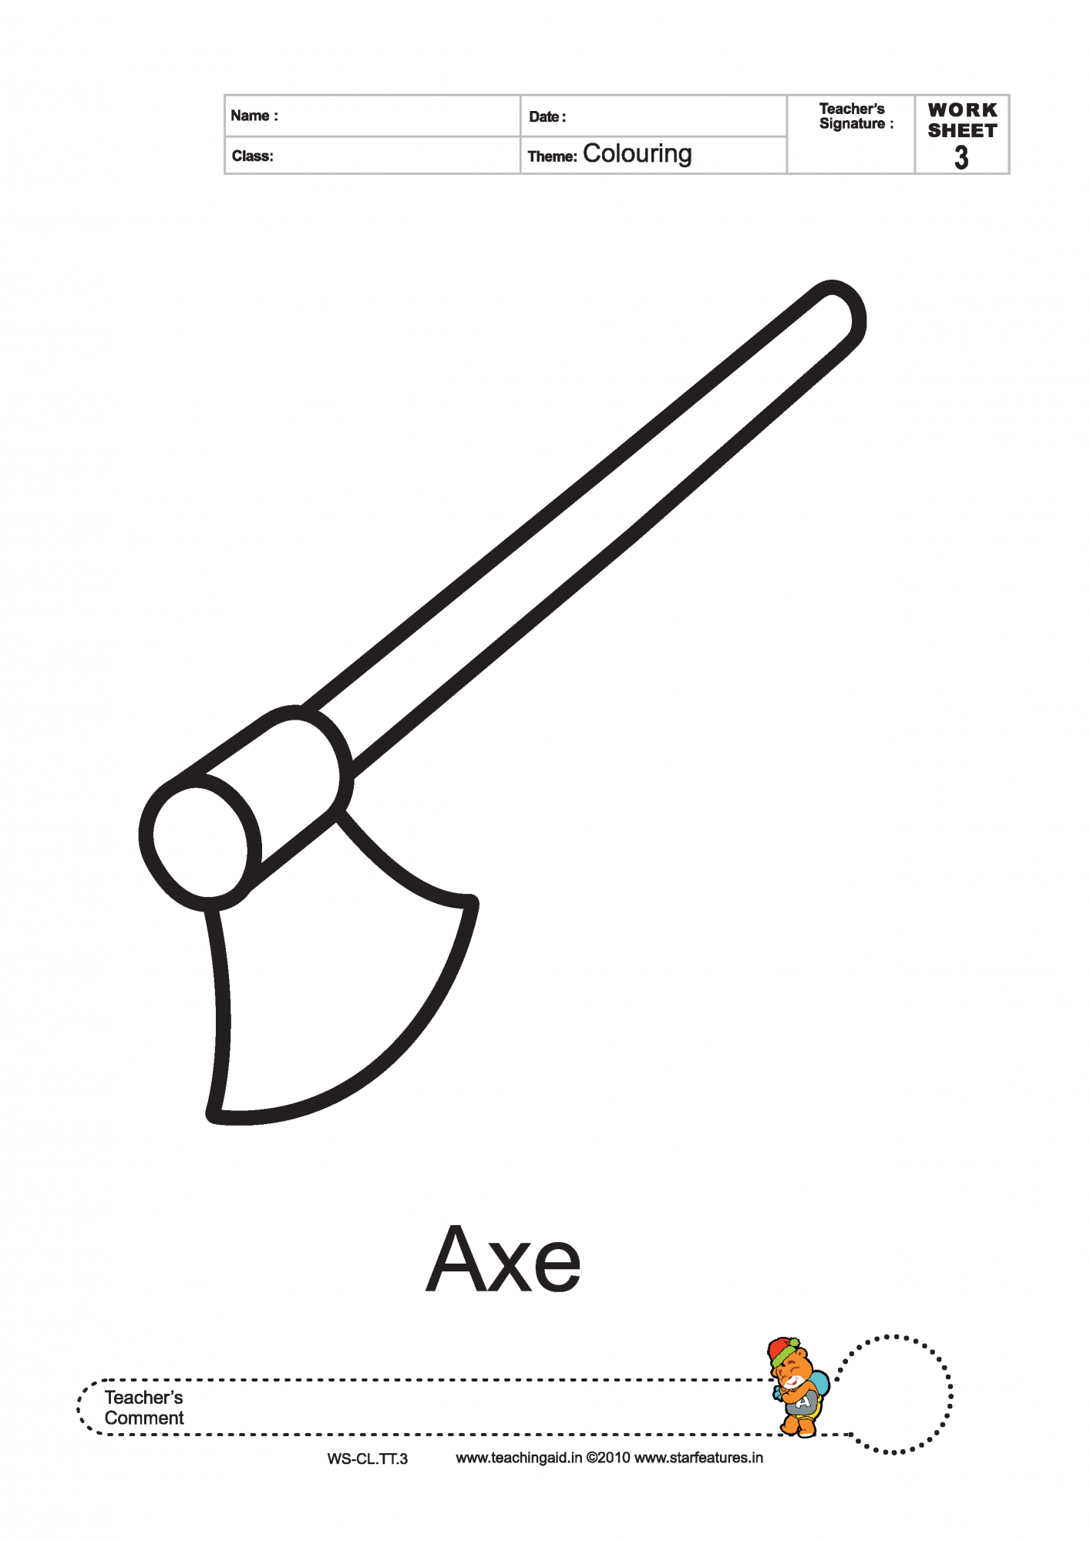

_________________

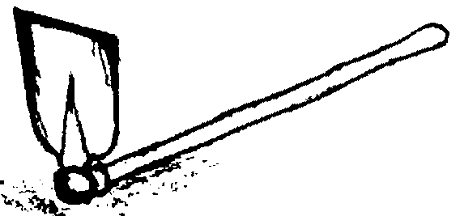

__________________

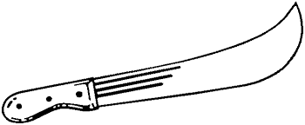

_________________

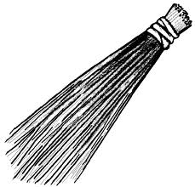

__________________

(panga, hoe, axe, broom)

1. **Colour the things found at home only.**

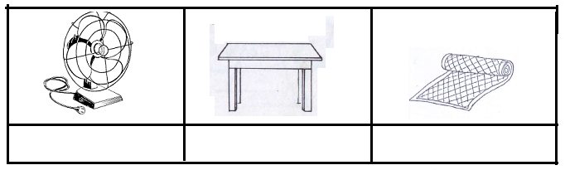

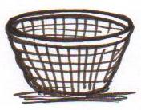

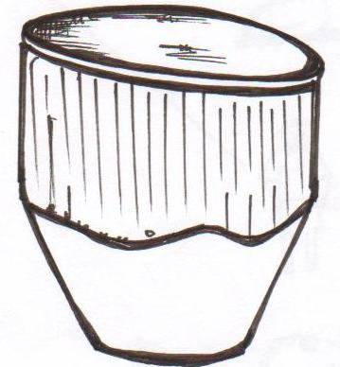

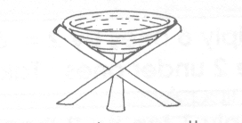

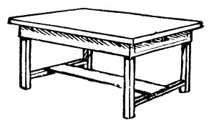

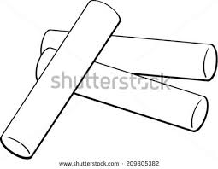

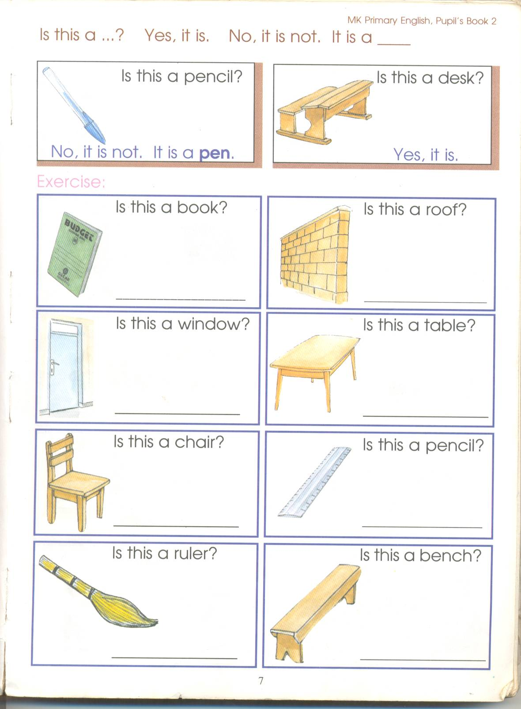

1. 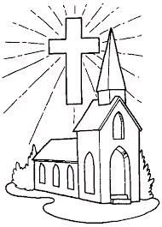**Name the important places.**

_________________

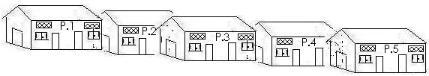

__________________

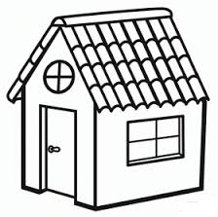

___________________

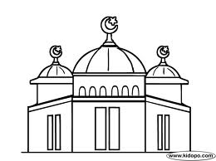

___________________

(mosque, school, church, hospital)

1. **Fill in the missing letters.**

br ___ther mo___her

s ___ster f___ther

b ____by